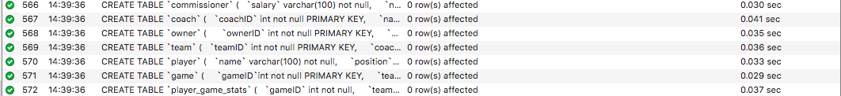

It was my understanding that the script log from mysql is what is required for this part of the project from my help with the TA. The log shows that the seven tables with foreign and primary keys in this databases were created successfully. The order is important because tables like “team” rely on foreign keys from tables that need to be created first. The complete code for every table creation, insert statement, update statement, and query are also included in one document in this zip file

The following is my insert statements and query statements successfully being completed. The full query statements are in the additional document with all of the mysql code which I referenced in the last paragraph. 